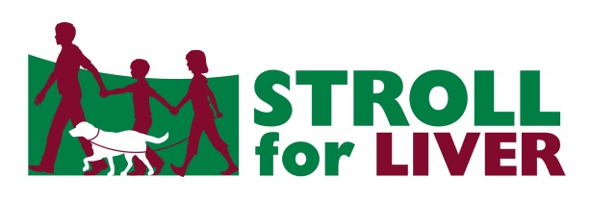
STROLL for LIVER Pledge Form
Please make cheques payable to the Canadian Liver Foundation. Tax receipts will be issued for pledges of $20.00 or more.
Please print clearly. Your complete address is required to produce a tax receipt.

Participant _________________________________
Address___________________________________
City _____________ Postal Code ______________
Phone ____________________________________
Email ____________________________________

Cash $__________________
Cheque $________________
Credit Card $ _____________ VISA, MC, AMEX accepted
TOTAL $_________________

Pledges will support liver research and education programs. Thank you!

 | Name | Address (include postal code please) | Pledge $ | Credit Card Number |  | EXP | Card Security No. | CASH/CHQ | Paid | Not Paid | OK for CLF to contact by email
1
 | Email: |  |  |  | Phone:
2
 | Email: |  |  |  | Phone:
3
 | Email: |  |  |  | Phone:
4
 | Email: |  |  |  | Phone:
5
 | Email: |  |  |  | Phone:
6
 | Email: |  |  |  | Phone:
7
 | Email: |  |  |  | Phone:
8
 | Email: |  |  |  | Phone:
9
 | Email: |  |  |  | Phone:

Contact: 1-800-563-5483 or clf@liver.ca

Privacy: The CLF respects your privacy. We protect your personal information & adhere to federal & provincial privacy legislation. For more information about the CLF’s Privacy Policy, please visit www.liver.ca or contact the CLF’s Chief Privacy Officer at 1-800-563-5483, email privacy@liver.ca. Canadian Charitable Registration No. 10686 2949 RR0001. The Canadian Liver Foundation is bringing liver research to life for Canadians of all ages living with or at risk of liver disease. In 2016, our goal is to invest approximately $2.9 million in liver research, public education, patient support and awareness. Estimated revenue for 2016 is $6 million with estimated fundraising costs of 25% and administrative costs of 26%.

